Pixel Art
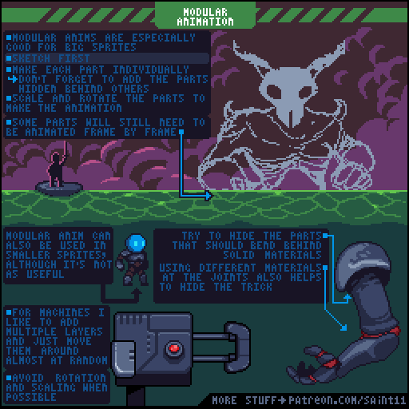

Ressources
- https://medium.com/pixel-grimoire/intro/home
- https://blog.studiominiboss.com/pixelart

